Task 1: Check Windows System Information

Objective
To identify the Windows operating system version, processor, and installed RAM.
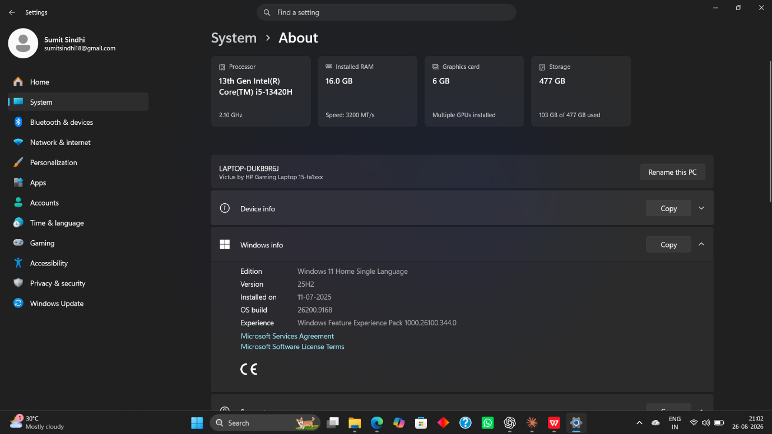

Task 2: Create a Bootable Linux USB

STEP1- Download ubuntu ISO file
STEP2- Download rufus latest version
STEP3- Insert USB drive and configure it
STEP4- Wait for completion
STEP5- Verify the boot USB
STEP6- Install the ubuntu in PC
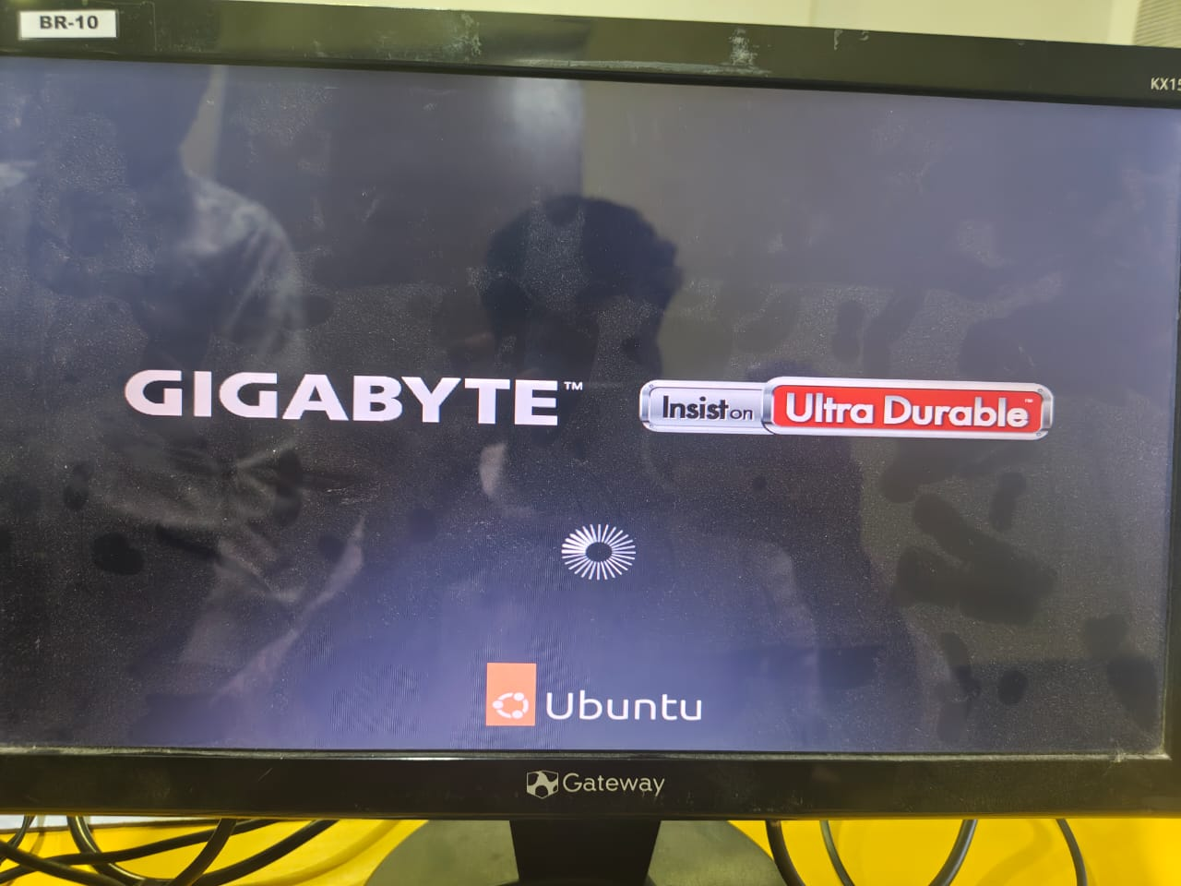

Task 3: Change macOS Wallpaper and Language

WALLPAPER CHANGE-
1.click on apple menu in top left
2.select system preferences
3.click on wallpaper
4.choose any wallpaper from available option
5.click wallpaper for apply
6.verfy from background that wallpaper has changed
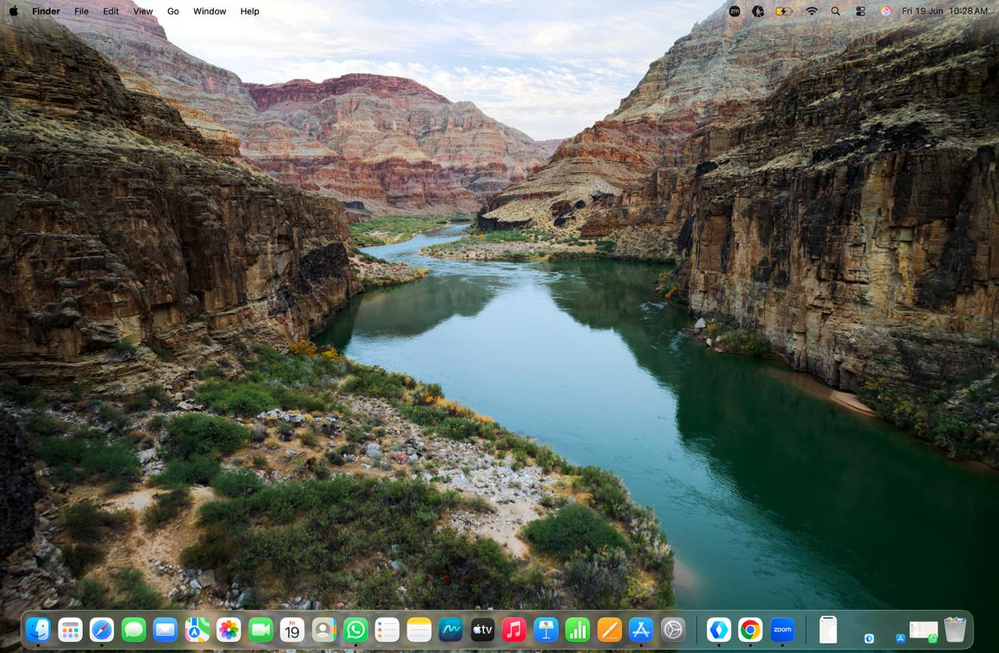
SYSTEM LANGUAGE CHANGE-
1.Open system preferences
2.click on general-region and language
3.click + to add language
4.select Hindi from list
5.click add
6.choose Hindi as primary language
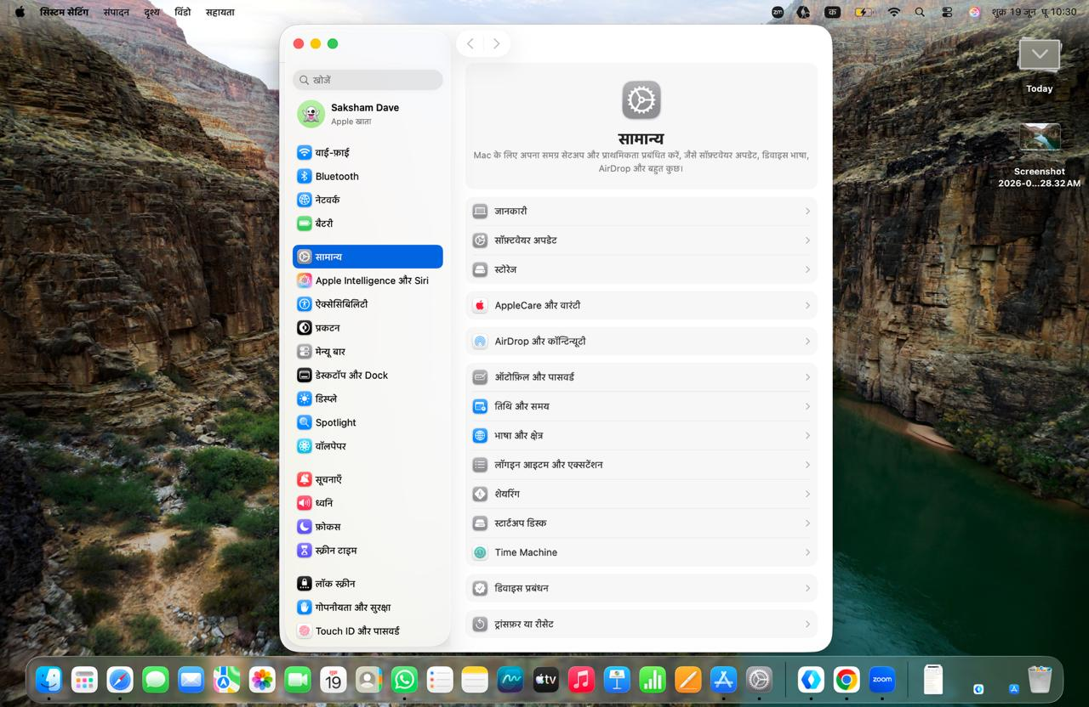
Task 4: Install Ubuntu and Create the gamer User

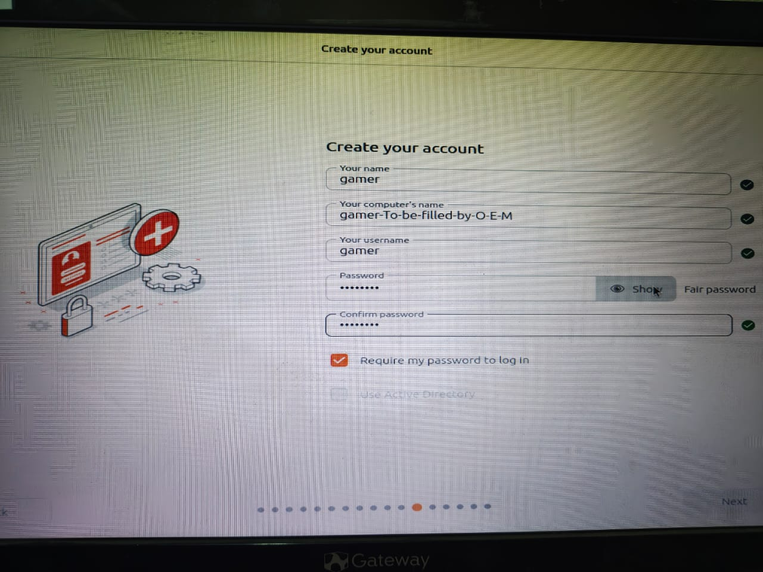
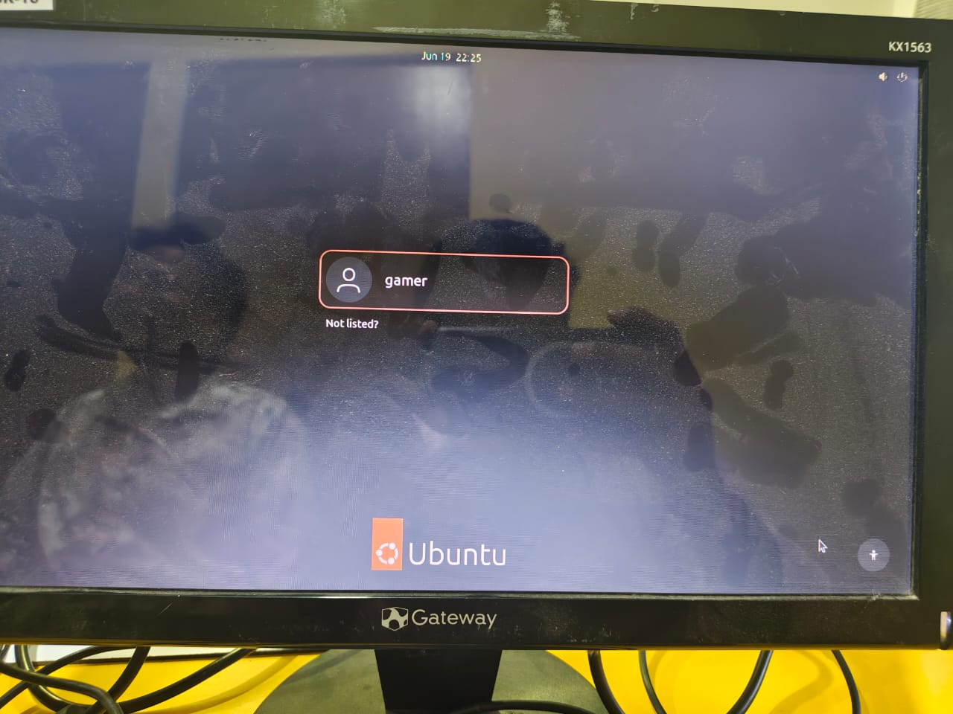

Task 5: AI-Generated Windows 10 Installation Guide

Requirements
- Windows 10 ISO
- Bootable USB (8 GB or larger)
- Backup of important files
Installation Steps
Step 1: Create Bootable USB
- Download Windows 10 ISO from Microsoft.
- Use Rufus to create a bootable USB.
Step 2: Boot from USB
- Insert USB drive.
- Restart the laptop.
- Open Boot Menu (F12/F10/Esc depending on device).
- Select USB drive.
Step 3: Start Installation
- Select language, time, and keyboard settings.
- Click Install Now.
Step 4: Partitioning Tips
- Select Custom Installation.
- Delete old partitions only if a fresh installation is required.
- Create:
  - C Drive: 100–150 GB for Windows
  - Remaining space for Data (D Drive)
- Select the C partition and click Next.
Step 5: Complete Installation
- Wait for files to copy.
- System will restart several times.
- Complete setup wizard.
Step 6: Privacy Settings
- Disable unnecessary location tracking.
- Turn off advertising ID if not required.
- Review diagnostic data options.
Step 7: Updates
- Connect to the internet.
- Open Settings → Update & Security.
- Install all available updates.

